**How to manually replace a corrupted system file with a known good copy of the file**

After you determine which system file was corrupted and could not be repaired through the detail information in the Sfcdetails.txt file, find where the corrupted file located, and then manually replace the corrupted file with a known good copy of the file. To do this, follow these steps:  
  
Note You may be able to get a known good copy of the system file from another computer that is running the same version of Windows with your computer. You may perform a System File Checker process on that computer to make sure the system file that you intend to copy is a good copy.

1. Take administrative ownership of the corrupted system file. To do this, at an elevated command prompt, copy and then paste (or type) the following command, and then press ENTER:

takeown /f **Path_And_File_Name**

Note The **Path_And_File_Name** placeholder represents the path and the file name of the corrupted file. For example, type takeown /f C:\windows\system32\jscript.dll.

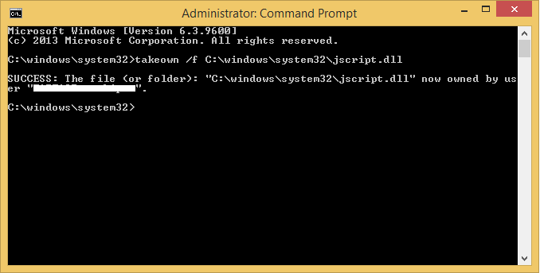

1. Grant administrators full access to the corrupted system file. To do this, copy and paste (or type) the following command, and then press ENTER:

icacls **Path_And_File_Name** /GRANT ADMINISTRATORS:F

**Note** The **Path_And_File_Name** placeholder represents the path and the file name of the corrupted file. For example, type icacls C:\windows\system32\jscript.dll /grant administrators:F.

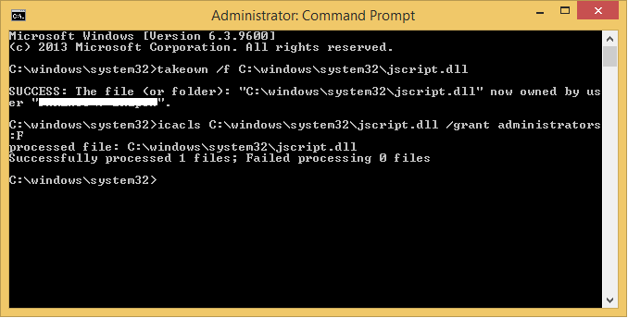

1. Replace the corrupted system file with a known good copy of the file. To do this, copy and paste (or type) the following command, and then press ENTER:

Copy **Source_File Destination**

**Note** The **Source_File** placeholder represents the path and file name of the known good copy of the file on your computer, and the **Destination** placeholder represents the path and file name of the corrupted file. For example, type copy E:\temp\jscript.dll C:\windows\system32\jscript.dll.